|  |  |
| --- | --- |
| Course Name | ITD 2313 – Script Programming |
| Instructor | <Michael Schnell> |
| Student Name | <Camden Stone> |
| Due date | <11/15/2020> |
| Grade | <grade earned here> |
| Grading Comments | <instructor comments here> |

Projects Week 10

#1

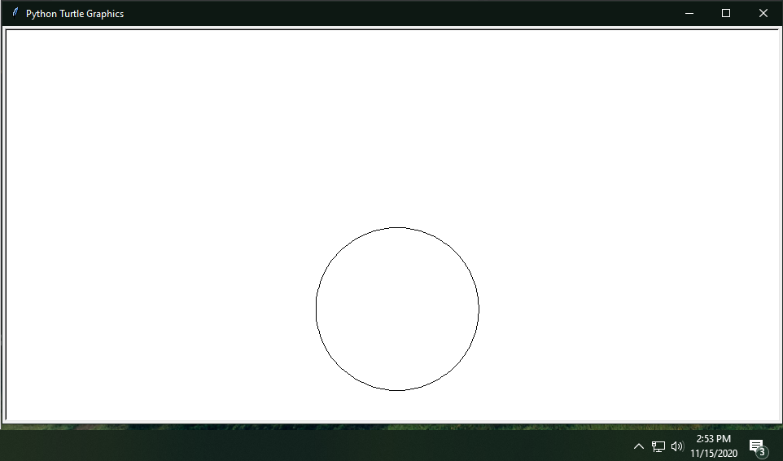

#2

Anything over 15 would break Turtle

